Getting Started with Downloading Data

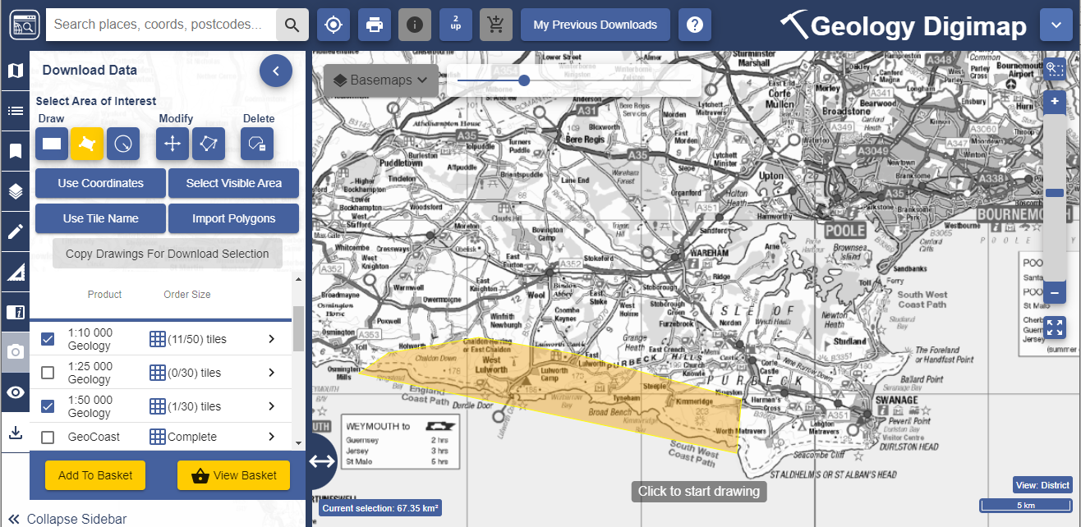

Contents
Contents 2
What is Downloading Data? 2
This guide 2
Get started 2
1. Select your area of interest 3
2. Select map data products 4
3. Basket options 5
4. Download data 6
To Reorder Data 6

What is the Downloading Data service?
Digimap offers the option to download geospatial data in a range of different formats for use in other application software (e.g. GIS and CAD). Formats available will depend upon the data product. The download function can be found in the left-hand panel of Digimap.
Downloading data is a straightforward 4 step process.

This guide
This Getting Started Guide is designed to introduce you to the steps involved in downloading map data. For a more detailed guide, see the Download Data User Guide.

Get started
- Login at https://digimap.edina.ac.uk
- Select your collection.
- Select Download Data from the side bar.
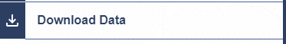

Select your area of interest

Find your location
The first step is to centre the map on your location.
Once you click the Download Data tab on the left, the maps in the map window are only to help you identify your area of interest. They do not reflect the map data you will download.
- Double click or double tap on the map to zoom into your location, or
- Search with place name, full or partial postcode, grid reference, easting & northing or latitude & longitude.

Select your download area on the map
When you have found your location, you need to select your area of interest on the map. You will receive map data for the area you select.
Go to the Select Area of Interest area on the sidebar. Options:
- Draw rectangle.
- Draw polygon.
- Create a point or line buffer.
- Use coordinates.
- Select visible area - this option will select the whole map window.
- Use tile name, for example NT27SE. In Geology and Marine you can enter Geology and Marine tile names.
- Import Polygons. You can import files in 3 formats; Shapefile, KML and GeoJSON. The maximum upload size is 10mb.

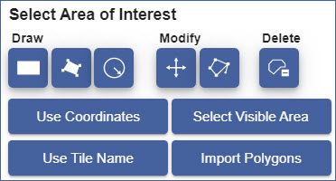

Ensure your area is highlighted in yellow on the map before you move on to Select Data Products.
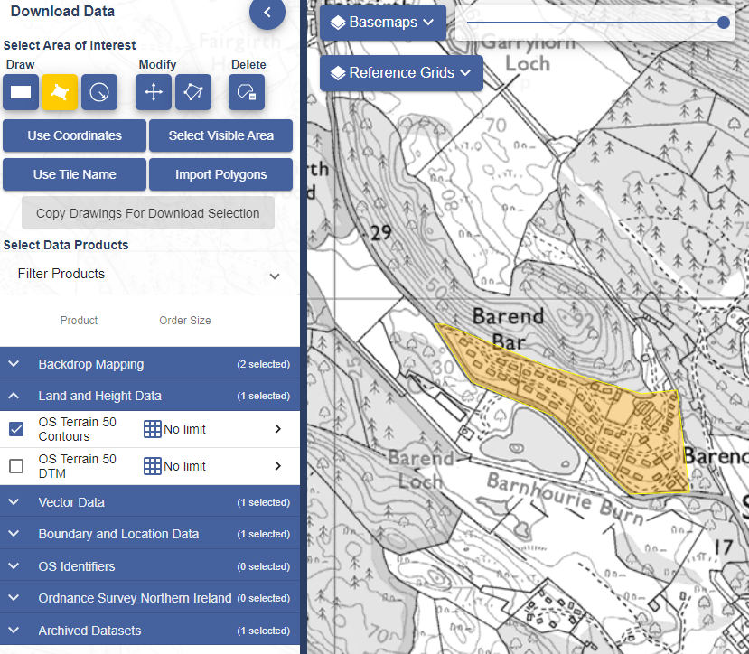

Select map data products
The Select Data Products area in the sidebar is typically grouped into categories, according to the data available in any given collection.

View and select products
- Select the down arrow next to any category to open it and see the available products.
- Select the right arrow next to any product for more details, e.g. date and formats.
- Check the box next to any data product(s) you wish to order.
  - You can order data from multiple categories.
  - You can order as many data products as you wish, but some products limit the amount of data you can request in one order.

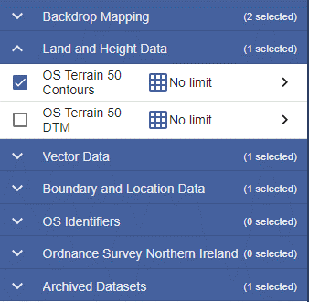

Add to Basket
- Selected all required products?
- Select Add to Basket button.
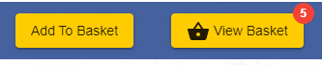

Basket options

Selecting options
- Select the drop-arrow(s) to select options.
- Options vary between products. Many products will not have any options.
- Select the bin icon next to any product to remove it from your order.
The Basket example we show here is taken from the Ordnance Survey Collection.

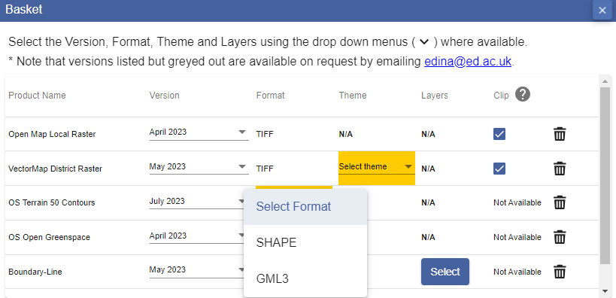

Place your order
- Name your order (optional).
- Check the email address is correct.
- Select Request Download.
- You will receive an email confirming your order.
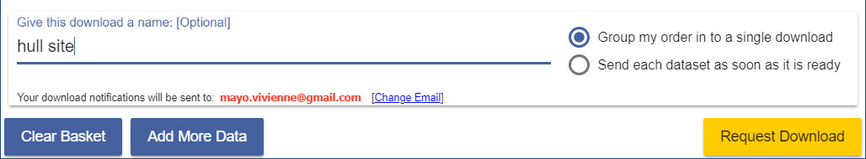

Download data

Order ready email
You will receive an order with a download link when your data is ready for collection.
- Select the Download your data button in the email.
- You will be prompted to login to Digimap if you are not already.
- A window opens confirming your order name, date and download size.
- Select the Download button.
- Save the file to your computer.
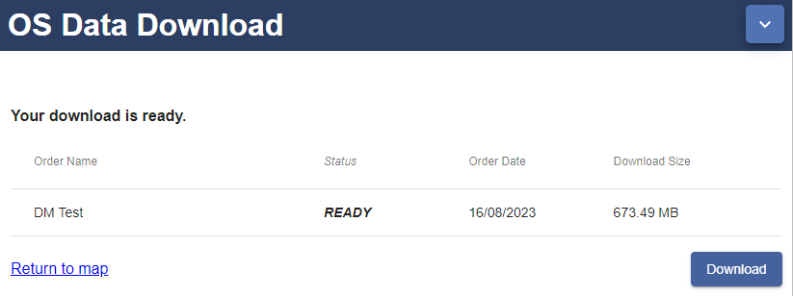

Download file
- Your data is downloaded as a zip file.
- You may have to Extract the data from the zip file, using your computer’s unzip or extract option.
- Each data product you ordered is within a sub-folder.
- Documentation will accompany your data, such as style files and a licence document.

To Reorder Data
- Login to Digimap.
- Select your collection.
- Select Download Data.
- Select My Previous Downloads, on the top toolbar.

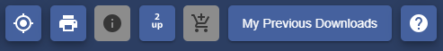

- Select any order you wish to reorder from the list.
- The details will appear under the list.
- Amend any of the product options or delete products, if required.
- Select Reorder.
