Download Data

User Guide

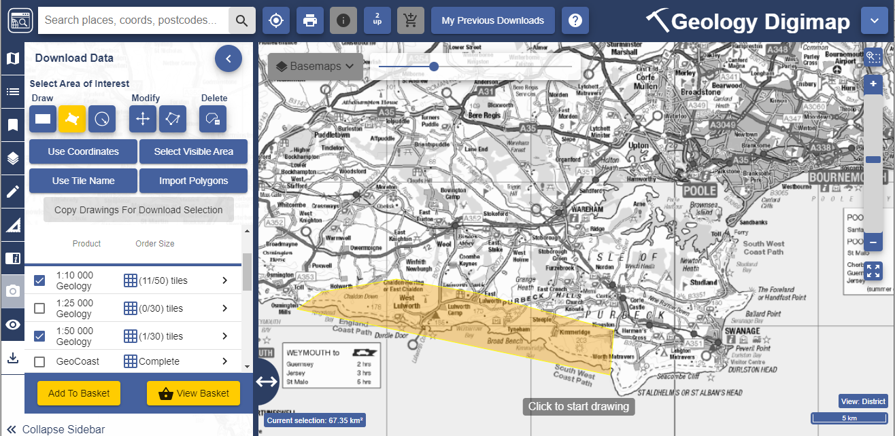

Contents
Contents 2
What is Downloading Data? 3
This guide 3
Get started 3
Find your location 3
Search box 4
Reference Grids 4
Select your area of interest 5
Draw Options 5
Use Coordinates 7
Select Visible Area 7
Use Tile Name 7
Import Polygons 8
Copying drawings for download 9
Select map data products 10
View available products 10
View product details 10
Select Products 10
Add to Basket 11
Basket options 11
Selecting options 12
Delete a map product 12
Add more data 13
Place your order 13
Download data 14
Download File 15
Reorder Data 15

What is Downloading Data?
Digimap offers a function which allows you to download raw map data for use in other application software such as GIS or CAD. You can find the data download function in the left hand panel of Digimap. The data in each collection are available in a range of different formats. The process of downloading data is the same in every collection, although there are variations in the products and formats available.

This guide
This User Guide is designed to introduce you to the steps involved in downloading map data. By the end of this guide you will be able to:
- Select your area of interest.
- Select your map data products.
- Select options, such as data format, date and style.
- Download your map data.

Get started

- Login at https://digimap.edina.ac.uk
- Select your collection.
- Select Download Data from the side bar.
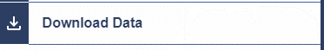

Find your location
The first step is to centre the map on your location.
Once you are viewing the Download Data tab in the left hand panel, the maps in the map window on the right are only to help you identify your area of interest. They do not reflect the map data you will download.
- Double click or double tap on the map to zoom into your location, or
- Select plus + on the scale bar or keyboard to zoom in, or
- Search.

Search box

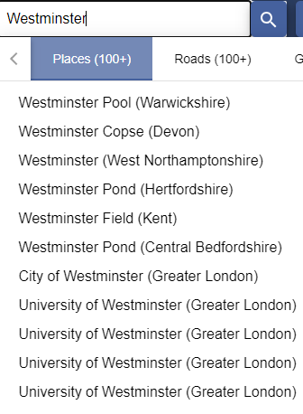
- Enter search term: place name, full or partial postcode, grid reference, easting & northing or latitude & longitude.
- Select magnifying glass icon.
- Select your place from the list.
- Your map is centred on your place.

Reference Grids
You can select a reference grid, such as postcodes or National Grid squares to overlay on your map. These are provided to help you identify your location.
- Select the Reference Grids button, on the map window.
- Select a reference grid. Note that the available grids will change as you zoom in or out.
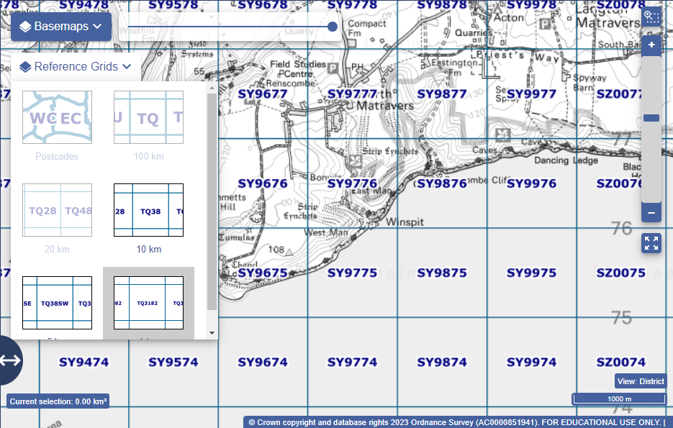

Select your area of interest
When you have found your location, you need to highlight your area of interest on the map. You will receive map data for the area you highlight.
There are several methods to help you do this, found in the Select Area of Interest on the sidebar.
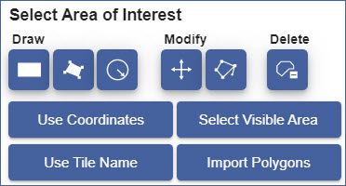

Draw Options
- Draw rectangle:
  - Go to the sidebar on the left of Download Data.
  - Select the draw rectangle tool, under Draw.
  - Click or touch the map where you want to start drawing your area.
  - Drag in any direction to draw your rectangle.
  - Click or touch again to finish.
  - Move on to Select Map Data Products.

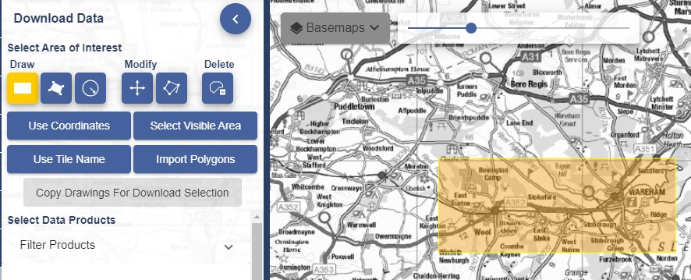

- Draw polygon:
  - Go to the sidebar on the left of Download Data.
  - Select the draw polygon tool, under Draw.
  - Click or touch the map where you want to start drawing your area.
  - Select the points on the map to draw your polygon.
  - Click or touch again to finish.
  - Move on to Select Map Data Products.
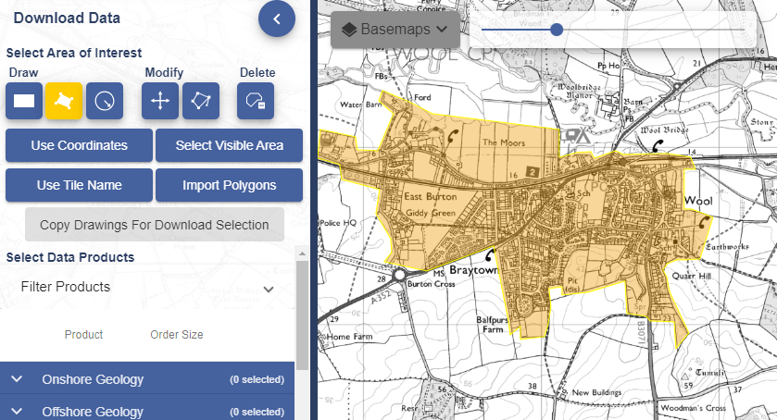

- Draw buffer:
  - Go to the sidebar on the left of Download Data.
  - Select the buffer tool, under Draw.
  - Select Point or Line buffer.
  - Enter the radius of your buffer, in metres or kilometres.
  - For a point buffer, select a point on the map to be the centre.
  - For a line buffer, click at each point of the line and double click to finish.
  - Your buffer will be highlighted on the map.
  - Move on to Select Map Data Products.

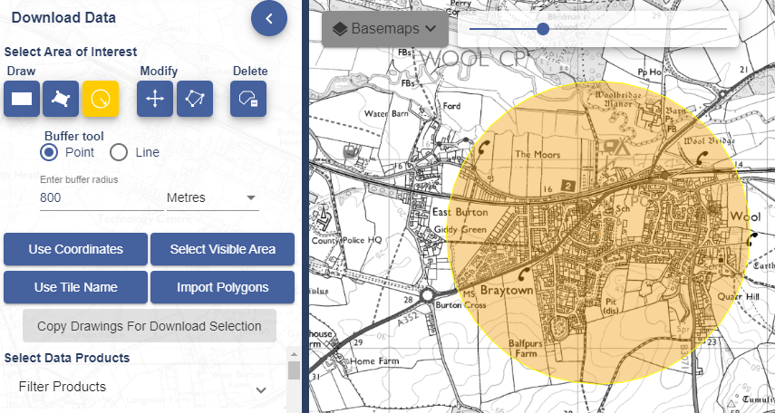

Use Coordinates

- Select the Use Coordinates button.
- Enter the coordinates for the upper right and lower left corners of your area.
- Select Go.
- Your area will be highlighted on the map.
- Move on to Select Map Data Products.

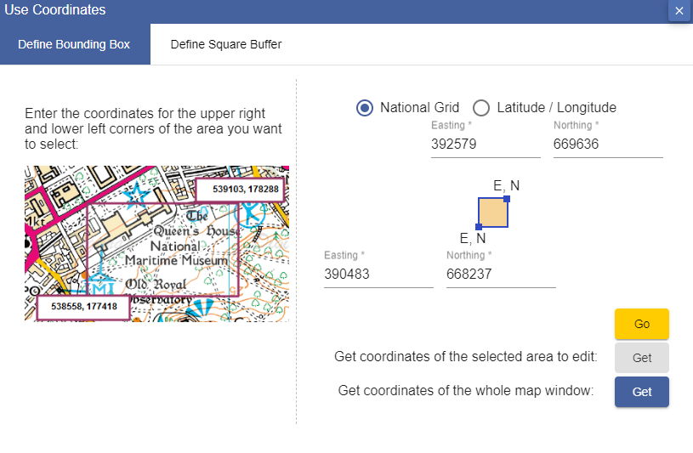

Select Visible Area

- Select the Select Visible Area button.
- The whole map window will be highlighted.
- Move on to Select Map Data Products.

Use Tile Name
Remember you can turn on reference grids to help you identify a tile name.
- Select the Use Tile Name button.
- Enter an Ordnance Survey tile, for example NT27SE. In Geology and Marine you can enter Geology and Marine tile names.
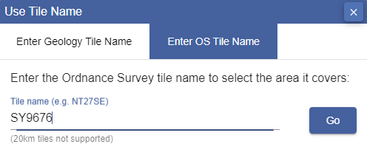
- Select Go.
- Your tile will be highlighted on the map.
- Move to on Select Map Data Products.
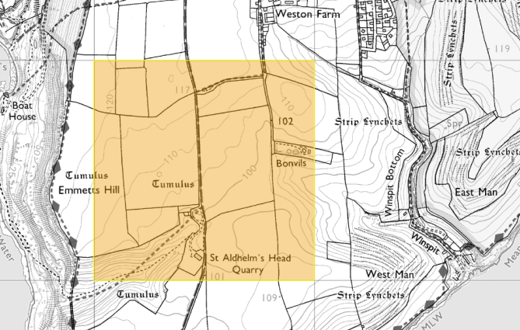

Import Polygons
You can import a file of polygons to identify your location(s).
Your file must be 10mb maximum.
Formats are Shapefile (zip), KML or GeoJSON.
- Select Import Polygons.
- Select Choose File.
- Navigate to your file.
- Select Import.
- Move to on Select Map Data Products.

Copying drawings for download
You can use your own drawing to select your area of interest for downloading.
- Create your drawing using the Drawing Tool.
- Click on the Download Data tool to move from one screen to another.
- Click on Copy Drawings For Download Selection, your drawing will appear.
- Move on to Select Map Data Products.

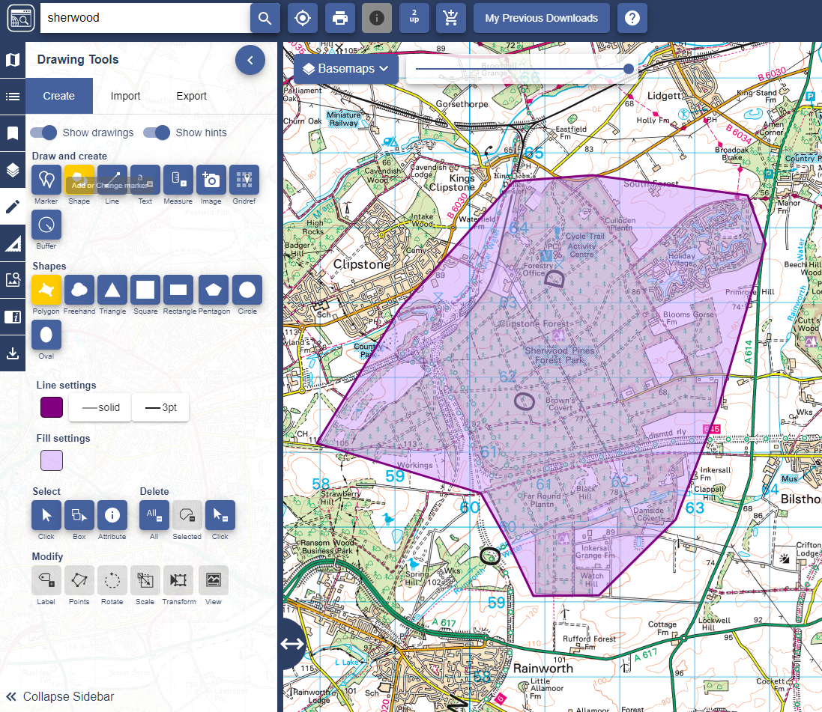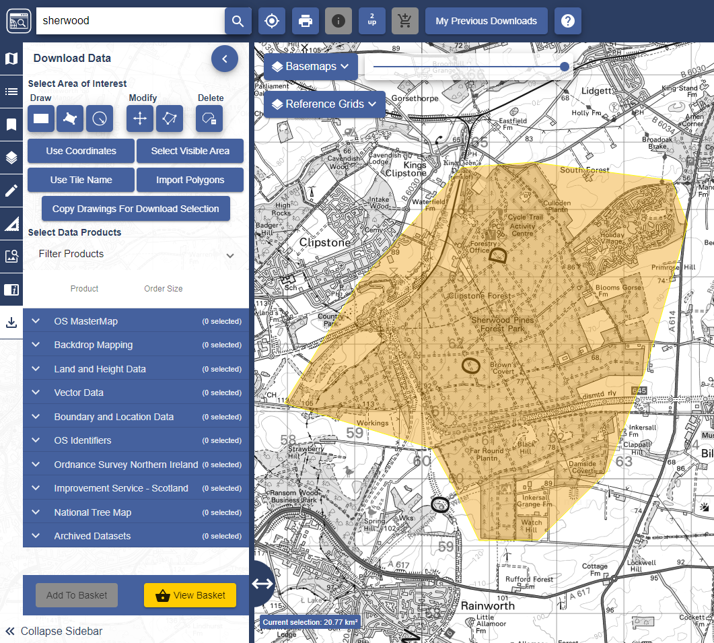

Select map data products
Each download tool has a Select Data Products area. The products are typically grouped into categories.

View available products
Select the down arrow next to any category to open it and see the available products.

View product details
- Select the right arrow next to any product.
- A Product Information box will open with details such as date and data format.
- Select More Info button for further details.
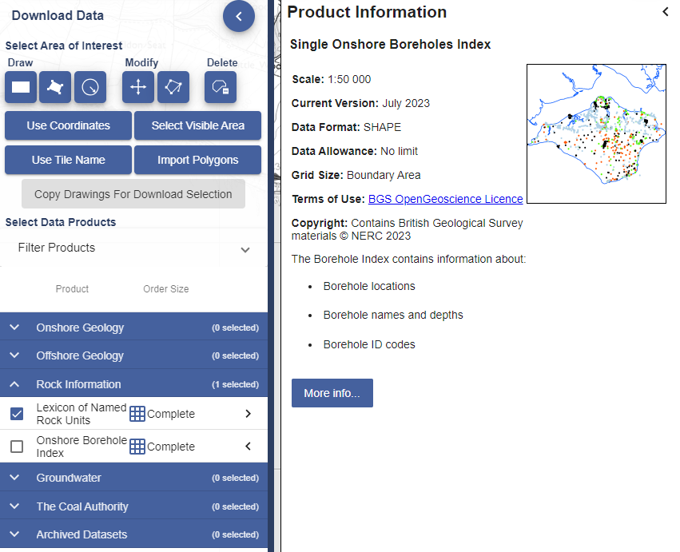

Select Products
- Check the box next to any data product you wish to order.
- You can order data from multiple categories – just open each category and select your required products.
- You can order as many data products as you wish, but some products limit the amount of data you can request in one order.
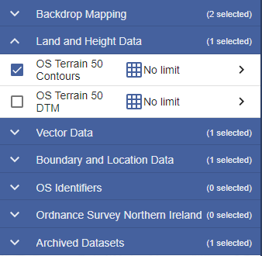

Add to Basket
- Selected all required products?
- Select Add to Basket button.
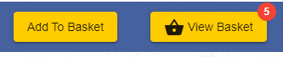
- Your basket will appear on screen.
- Move on to Basket Options.

Basket options
Product options vary depending on the product, but may include a combination of the following:
- Version - the date the map data was published.
- Format – some products have more than one format available.
- Theme – if the product is available in more than cartographic style. For example, OS MasterMap has standard (full colour) or plan (line style).
- Layers – you may be able to select layers of map features, such as Buildings, Roads etc.
- Clip – this option controls how data is extracted for your selected area.

Selecting options
- Select the drop-down arrow(s) to select options.
- Remember that some data products will not have any options.
The Basket example we show here is for Ordnance Survey Download Data.
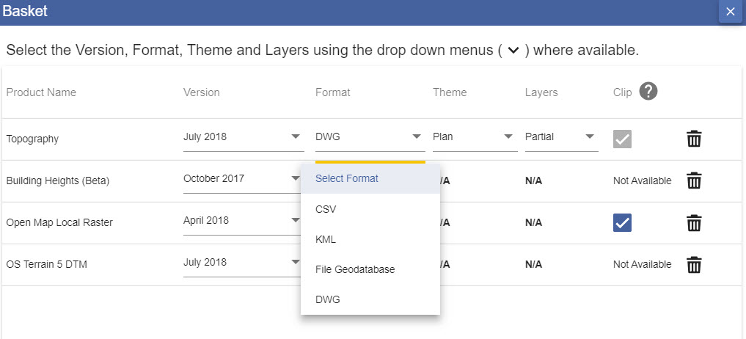

Delete a map product
Select the bin icon next to any product to remove it from your order.

Add more data
- Select the Add more data button.
- Make your data selections.
- Select Add to Basket.

Place your order
- Name your order (optional).
- Check the email address is correct.
- Select Request Download.
- You will receive an email confirming your order.

Download data
- You will receive a second email with a download link when your data is ready for collection.
- Select the Download your data button in the email.
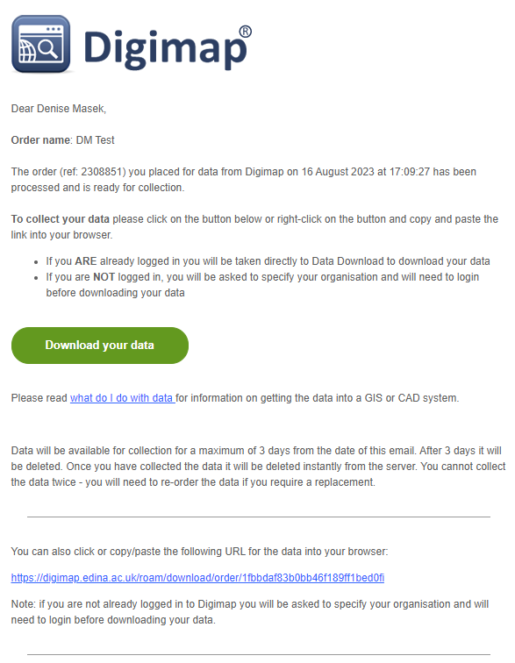

- You will be prompted to login to Digimap if you are not already.
- A window opens confirming your order name, date and download size.
- Select the Download button.
- Download the file to your device.
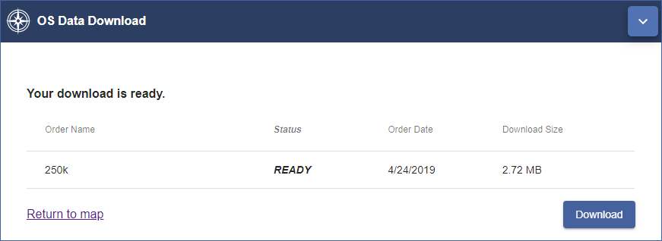

Download File
- Your data is downloaded as a zip file.
- Most devices will offer an Extract option, to extract the files from the zip. Depending on your software’s requirement, you may not need to extract the files.
- 2 text files are provided:
  - One file gives citations for your data products.
  - Another file details the contents of your order.
- Each data product you ordered is within a sub-folder. The image below shows 4 data sub-folders.

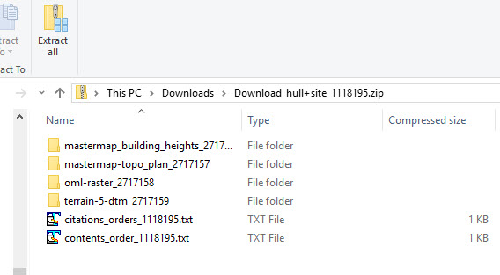

- Within a product sub-folder, you will typically find:
  - A folder or folders containing the data files.
  - A licence document, explaining the terms of use for that product.
  - Any supporting documents with information on using the product including style files.

Reorder Data
- Login to Digimap.
- Select your collection.
- Select Download Data.
- Select My Previous Downloads, on the top toolbar.

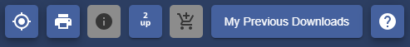

- Select any order you wish to reorder from the list.
- The details of the order will appear under the first list.
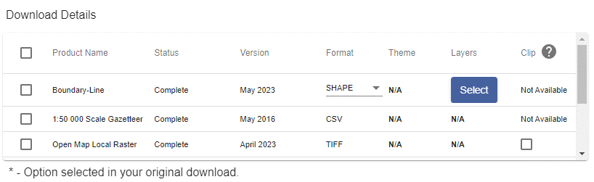
- Select the product(s) you wish to reorder.
- Amend any options.
- Rename your order (optional).
- Select Reorder.

