

Getting Started Guide

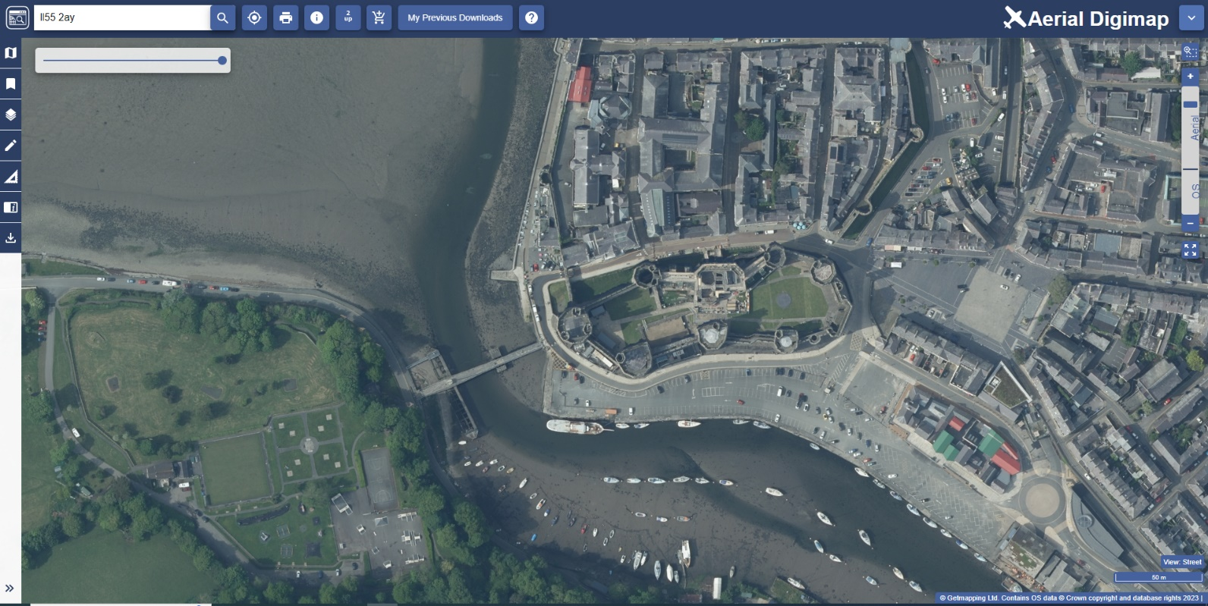
- Find your location
- Browse maps
- Customise map feature display
- Add shapes, text and data
- Measure map features
- Add overlays
- Compare 2 maps
- Save and print

Contents
Contents 2
What is Digimap? 2
This guide 2
Get started 3
Find your location 3
Search box 3
Browse maps 4
Basemaps 4
Sidebar options 5
Customise Map content 5
Measure map features 6
Add shapes and text 6
Add Overlays 7
Compare Two maps 7
Save and open maps 8
Print 8

What is Digimap?
Digimap is an online application which allows you to use pre-built maps and to download map data with which to make your own maps. For the purposes of these guides, the two main functions are defined as mapping and data download. Pre-built maps can be scaled and annotated using a range of online tools, ready for printing or use in other electronic documents. Map data is available for download in a range of formats suitable for use in other application software such as GIS or CAD.

This guide
This Getting Started Guide is designed to introduce you to the key features of map making with Digimap. By the end you will be able to view, customise and print maps.
For a comprehensive guide to all Digimap features, check out our User Guide.

Get started
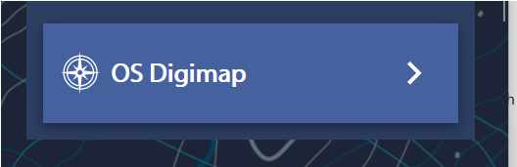
- Login at https://digimap.edina.ac.uk
- Select your collection.
- Select the application you need from the appropriate collection.

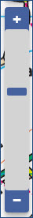
Find your location
- Double click or double tap on the map to zoom into your location, or
- Select plus + on the scale bar or keyboard to zoom in, or
- Search using the search box.

Search box
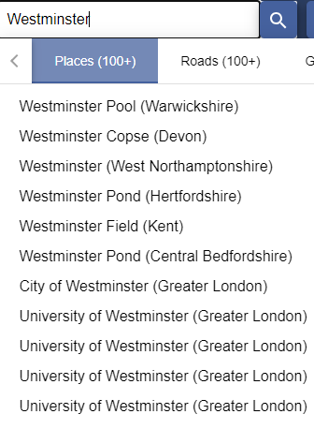
- Enter search term: place name, street name, full or partial UK postcode, British National Grid reference, easting & northing or latitude & longitude.
- Select magnifying glass icon.
- Select your place from the results list – note more than one results list may be displayed.
- Your map is centred on your place.

Browse maps
Digimap offers a range of maps, displayed at different scales. Zoom in and out to see what’s available:
- Zoom in:
  - Double click or double tap.
  - Select plus sign + on scale bar.
  - Select plus sign + on the keyboard.
  - Draw a box with the zoom tool above the scale bar.
  - Move mouse scroll wheel forward.
- Zoom out:
  - Select minus sign - on the scale bar.
  - Select minus sign - on the keyboard.
  - Move mouse scroll wheel backward.
  - Select the Zoom to maximum extent button (under the scale bar) to zoom out as far as possible.
- Click/touch and drag the map in any direction to move around.

Basemaps
Several collections offer different map styles for selected scales.
1. Select the Basemaps button on the map.
2. Select the Basemap that fits your needs.
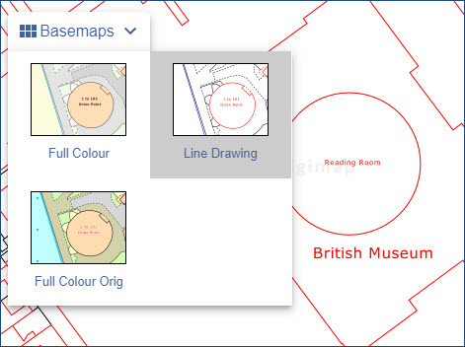

Sidebar options
Several options are available in the sidebar.
- Select Collapse Sidebar to hide the panel and display more map.
- Move the double arrow left or right to change the width of the sidebar.
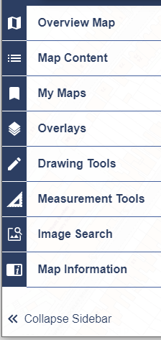

Customise Map content
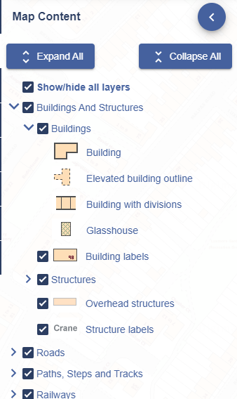
In several collections, you can choose what features to display on the map.
- Select Map Content from the sidebar.
- Select the arrow left of any box to view the features in that group.
- Uncheck any box to remove those features from your map.
- TIP: 'This view has no layer selection' means you can't select map features (because of the type of map data on display). Try a different basemap to see if feature selection is available.

Measure map features
Select Measurement Tools from the sidebar to measure distances and areas on your map.
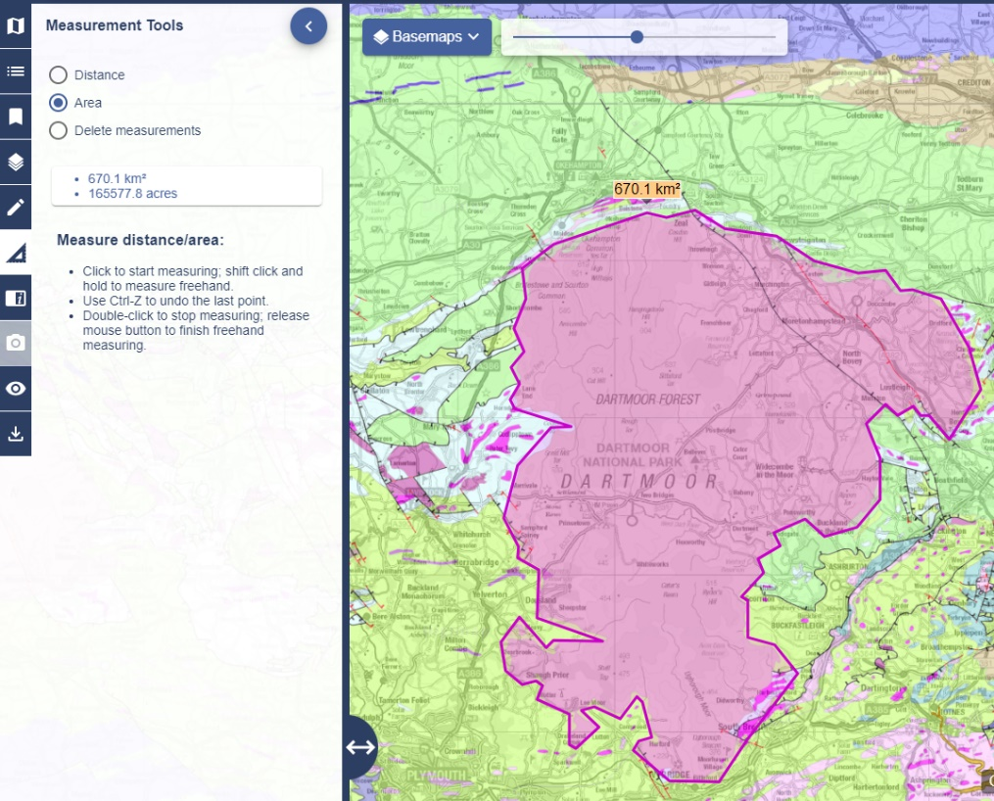

Add shapes and text
You can add text, markers, pre-defined shapes, buffer zones and polygons to your map.
Select the Drawing Tools from the sidebar and have fun!

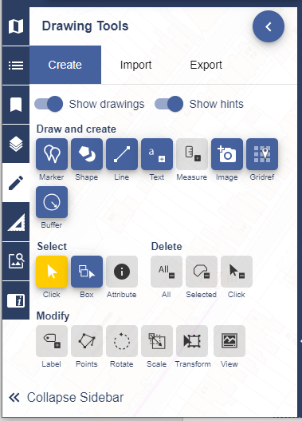

Add Overlays
Not available in every collection.
Select Overlays to add more data to your map. Depending on the collection you are using and the scale of the map you are viewing, you may be able to add:
- Points of Interest – point locations of features such as educational institutions, doctors, shops and many more.
- Contours and Spot Heights
- Postcodes – see image below
- Hill Shading – adds a 3D terrain map

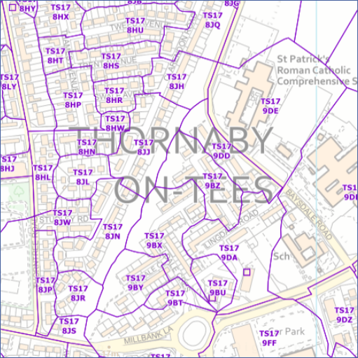

Compare Two maps
Not available in every collection.
- Select the 2up button, above the map window.
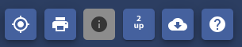
- Select a map on each map window using the Basemaps button.
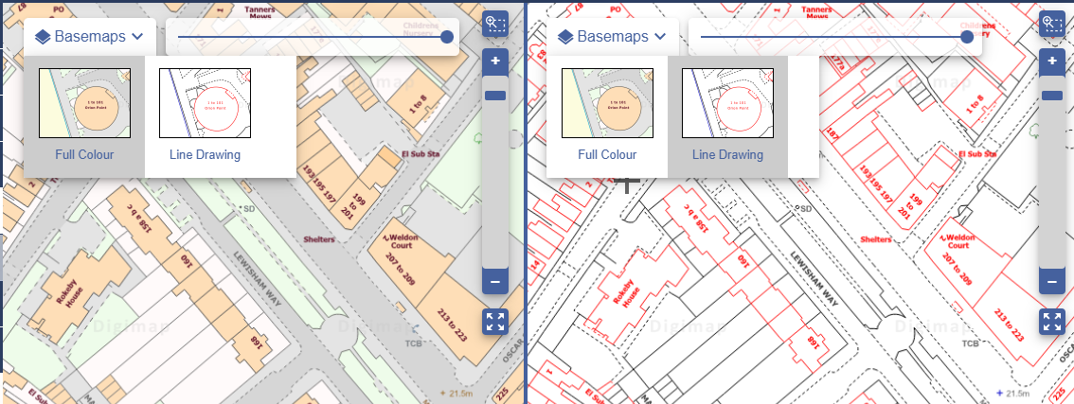
- Note: if you want to customise which map features are displayed, you can only do this on the map visible in the left map window.

Save and open maps
- Select My Maps from the sidebar.
- Save – to save your map and drawings, enter a name and Select Save.
- Open – just select any map to retrieve and display it.

Print
Generate a PDF/JPG/PNG for printing at a range of scales.
- Open the Print box, found above the map.
- Print Scale – a default print scale is given. You can choose a different scale – just type it in the box. Your scale must lie within the scale range given.
- Layout Preview – select this tab above the map to see what area your map covers. Can be useful in determining the right print scale.
- Add a title, select format, page size, layout and any additions.
- Select Generate Print File to download your file.

Printer options
NOTE: when you print your map from your computer, make sure you choose to print at ‘actual size’. If you choose the ‘fit to page’ option that is offered by many print tools your map scale will change.
