

Digimap User Guide

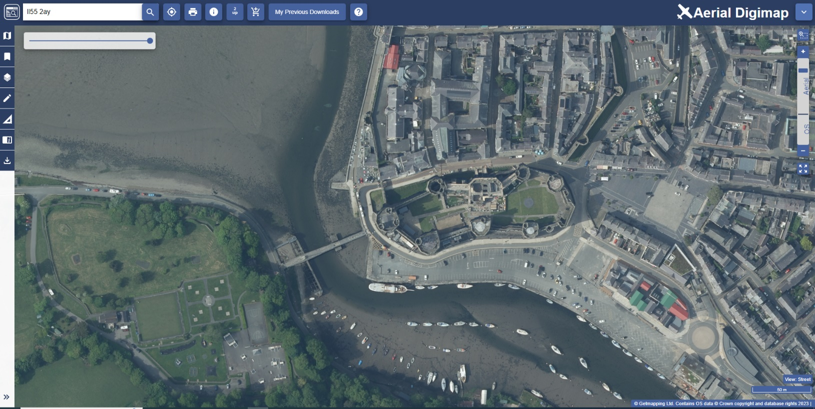

Contents
Contents 2
What is Digimap? 4
This guide 4
Login 4
Map Window 5
Find your location 5
Browse maps 5
Move around 6
Basemaps 6
Transparency slider 7
Timeline 8
Top toolbar 9
Search box 9
Print 10
Printer options 10
Locate position tool 11
Compare two maps 11
Feature information tool 12
Data Download button 13
Sidebar 13
Map information 14
Coordinate Capture Tool 15
Map content 16
Drawing tools 16
Measure 18
Save and open maps 19
Overlays 20
Add a Web Map Service (WMS) 22
Add map data 24
Overview map 24
Active Legend 25
Geological Photos 25
Save screen image 26
Overlapping map selection 27
Copyright 28
What can I do with maps from Digimap? 28
What is the correct copyright statement? 28
Find Help and Support 28

What is Digimap?
Digimap is an online application which allows you to use pre-built maps and to download map data with which to make your own maps. For the purposes of these guides, the two main functions are defined as mapping and data download. Pre-built maps can be scaled and annotated using a range of online tools, ready for printing or use in other electronic documents. Map data is available for download in a range of formats suitable for use in other application software such as GIS or CAD.

This guide
This User Guide details all features of map making with Digimap.
By the end you will be able to view, customise and print maps, add your own data to maps and identify information about maps and map features.
For a shorter guide to help you get started with map making, see our Getting Started Guide.

Login
- Login at https://digimap.edina.ac.uk
- Select your collection.
- Select the application you need from the appropriate collection.

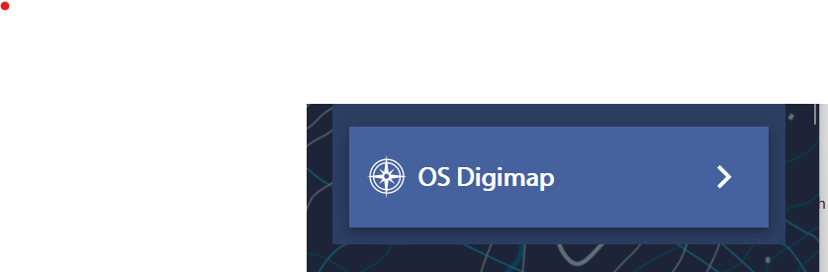

Map Window
Maps are displayed in the map window. You can zoom in and out and move the map around.
The scale bar, on the right of the map window, is one method for zooming in and out of maps.

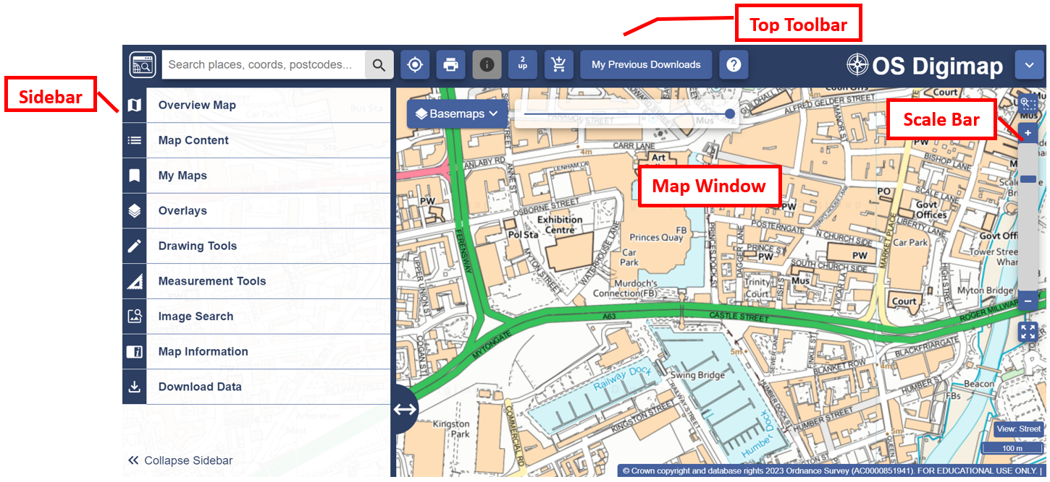

Find your location
- Double click or double tap on the map to zoom into your location, or
- Click plus on the scale bar to zoom in, or
- Search using the search box.

Browse maps
Digimap offers a range of maps, displayed at different scales. Zoom in and out to see what’s available:

Zoom in:
  - Double click or double tap.
  - Select the plus sign + on scale bar (see image below).

  - Use the plus sign + on your keyboard.
  - Move mouse scroll wheel forward.
  - Draw a box with the zoom tool above the scale bar (see image below).

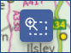

Zoom out:
  - Click minus sign – on the scale bar.
  - Use the minus sign – on your keyboard.
  - Move mouse scroll wheel backward.
  - Select the zoom to maximum extent button to zoom out as far as possible.

Move around
- Click/touch and drag the map in any direction to move around.

Basemaps
Several collections offer different Basemaps at selected scales.
These may be the same map data presented in a different cartographic style, or a map with different features that is suitable for display at your current scale.
- Select the Basemaps button on the map window.
- Select any Basemap you want to view.
- Your map will update with your selected Basemap.
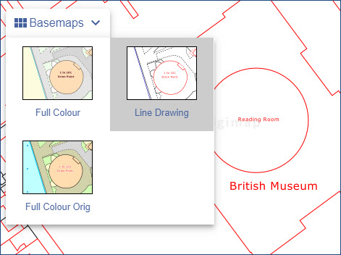

Transparency slider
Some collections offer a transparency slider on the map window. By moving the slider left or right, you can adjust the transparency of the map display. In Environment Digimap, for example, you could choose not to see any background map and only see the environment mapping. Two images are shown below for comparison.
- Just drag the transparency slider left or right to try it out.
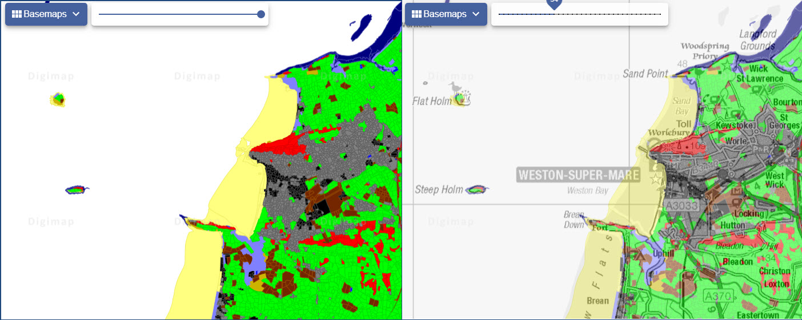

Timeline
Only found in Historic Digimap, the timeline allows you to select a decade and view the available maps from that time period.
As you zoom in and out of the historic maps, remember there is a wide range of different scales and dates available. Not every town or county was surveyed every decade, so you may find there is not a map for your area of interest at every scale.
In the image below, we are viewing a 1900s map of Sheffield.
- Find your location.
- Zoom in to a historic map.
- The timeline above the map window activates.
- Select any highlighted decade to view a map from that decade. If the decade is greyed out, there are no maps available at this scale.
- Remember the highlighted decades will keep changing as you zoom in or out.
- Get the text: ‘no historic maps of this location are available…’? You need to zoom in/out or switch decade.
Tip: In larger towns and cities, keep zooming in! There may be Town Plan maps available. These were highly detailed maps, produced between 1840s and 1930s.
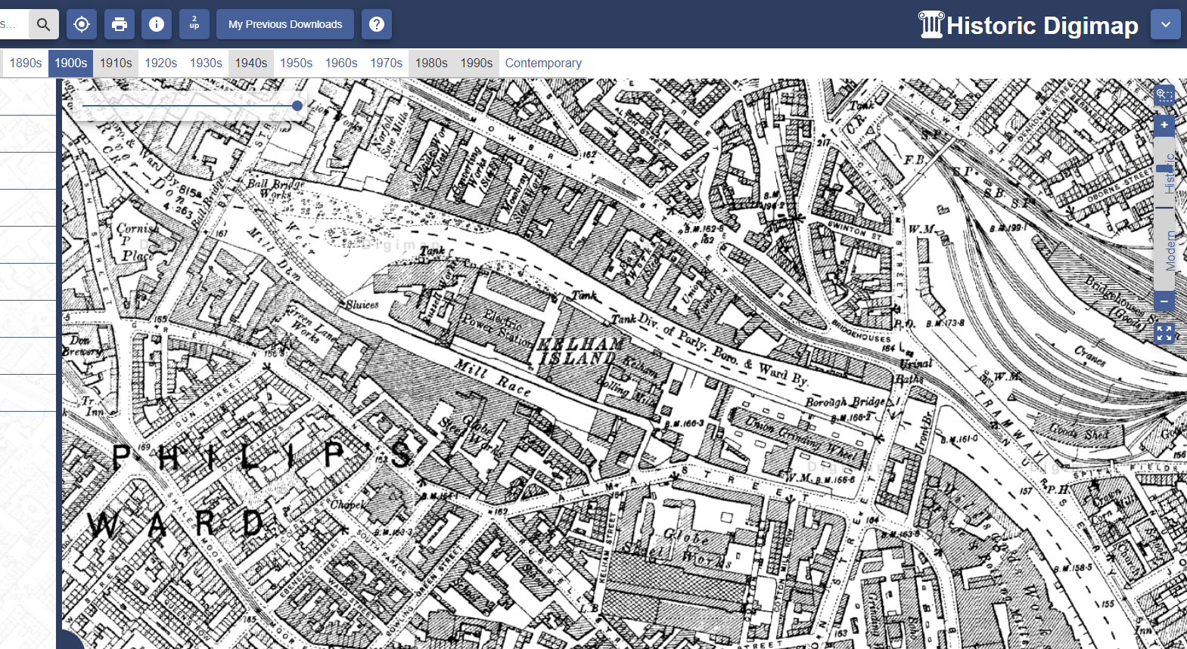

Top toolbar
- The Search box is available on the top toolbar.
- Locate my Position tool will zoom you to your current physical location.
- Print tool is available here.
- My Previous downloads
- Go to Help Page
- Other options vary between collections, but may include:
  - 2up: compare 2 maps.
  - Get Feature Information: select features on the map window and view the data we hold for them.
  - Add basemap to download basket.

Search box
The search box is found in the top toolbar at the left.
- Enter search term: place name, street name, full or partial postcode, grid reference, easting & northing or latitude & longitude.
- Select magnifying glass icon.
- Select your place from the list – note that more than one results list may be displayed.
- Your map is centred on your place.
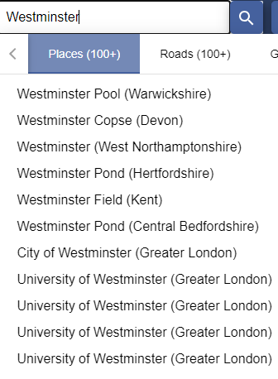

Print
The print menu is available on the top toolbar. Generate a PDF/JPG/PNG for printing at a range of scales.
- Open the Print menu, found on the top toolbar.
- A default print scale is given. You can choose a different scale – just type it in the box. Your scale must lie within the scale range given.
- Layout Preview – select this tab above the map to see what area your map covers. Can be useful in determining the right print scale.
- Add a title (optional).
- Select format, page size and layout.
- Additions - optional:
  - You can include your name from your Digimap account registration. If you choose not to include your name, your department, institution and the date of printing are included.
  - Annotations – if selected, this will include any drawings you have added to your map.
  - National grid lines – British National Grid lines will be added to your map.
  - Hill shading – add the 3D terrain data to your map.
  - Legend – this is provided as a separate PDF file.
- Select Generate Print File to download your file.
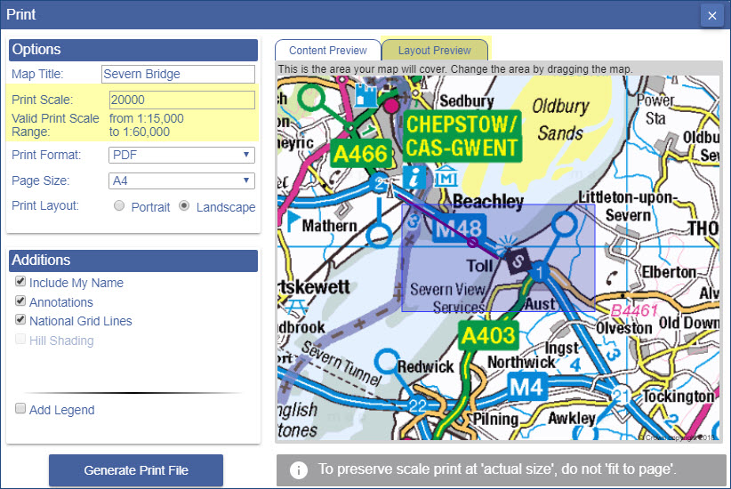

Printer options
NOTE: when you print your map from your computer, make sure you choose to print at ‘actual size’. If you choose the ‘fit to page’ option that is offered by many printing tools your map scale will change.

Locate position tool
The locate position tool, found on the top toolbar, will zoom your map to your current geographical location and place a marker of your location on the map.
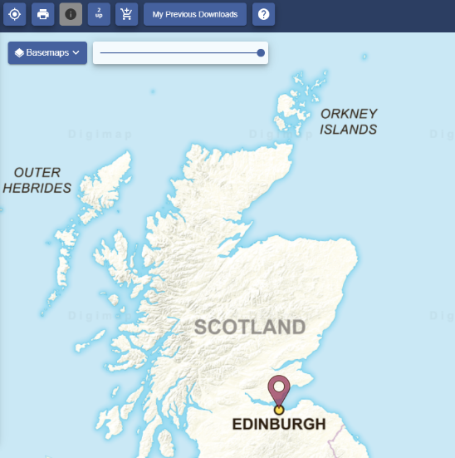

Compare two maps
Several collections offer 2up view on the top toolbar, which enables you to compare 2 maps side by side.
- Find your location.
- Select the 2up button from the top toolbar.
- Collapse the Sidebar.
- You should be able to see the same map in the 2 map windows.
- Now you can select a different map to view, either on the right or the left.
  - In Historic, use the timeline to select two decades of your choice. You can use the double arrow at the left and right of each timeline to move along it.
  - In Ordnance Survey, Geology and Environment you can select a different basemap for comparison.
  - In Marine, you can change the map content on one map for comparison.
  - In Aerial, you can move the transparency slider on one map for comparison.
- Select 2up again to view one map.

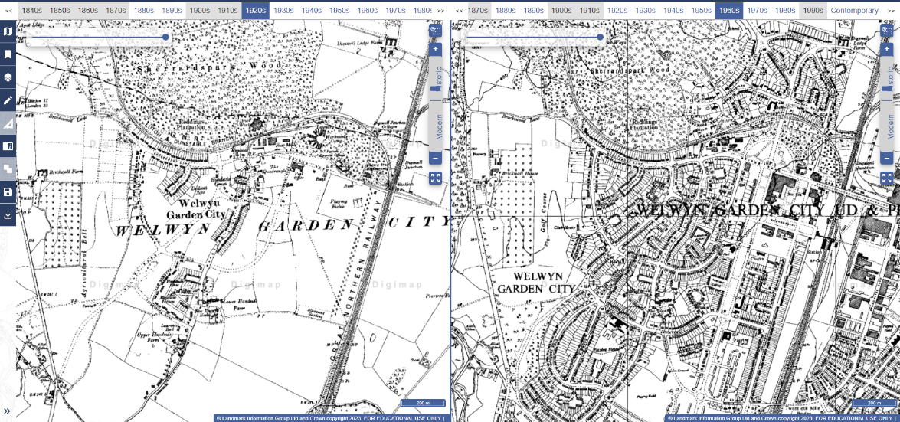

Feature information tool
Several collections offer a Feature Information Tool, found on the top toolbar. It identifies different features (or map information) in different collections. The table below tells you what the tool identifies in different collections.


Using the tool
- Select the information icon from the top toolbar.
- Select the feature on the map you want to identify.
- A box will pop up displaying feature or map information.

What is identified?
Ordnance Survey | Geology | Historic | Aerial | Environment | Marine
Only available when you are viewing two overlays (Points of Interest or Contours and Spot Heights). | Varies by Basemap – rock type, soil, flooding indicator or permeability information. | Details of the Historic map(s) on display: map series, scale, edition, county/town and year of publication. | National Grid reference and the date of the aerial imagery. | Class from the Land Cover map on display, e.g. arable and horticulture. | All features from Marine Themes Vector data identified at that point, select from a table.

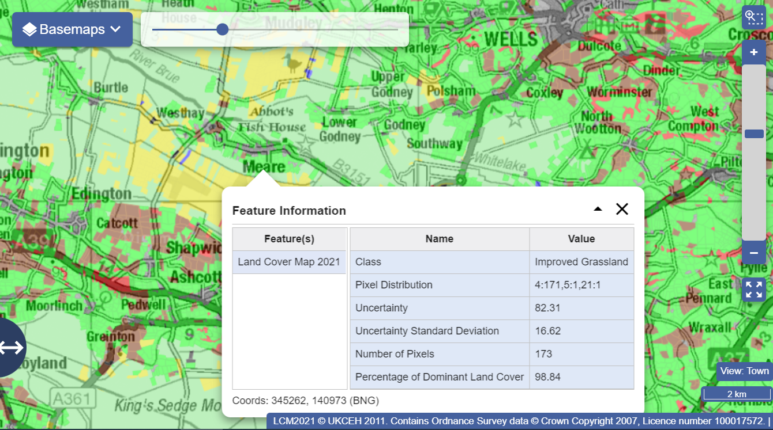

Data Download button

- Selecting the Download Data icon on the sidebar will allow you to download your data. For more information, please read 'Download Data' User Guide.The Downloading map window will have a yellow area highlighted. This area reflects the map you were viewing.
- You can now go ahead in Download Data and select any map data products you wish to download.

Sidebar
Several options are available in the sidebar, on the left.
- Select Collapse Sidebar to hide it and display more map.
- Move the double arrow left or right to change the width of the sidebar.
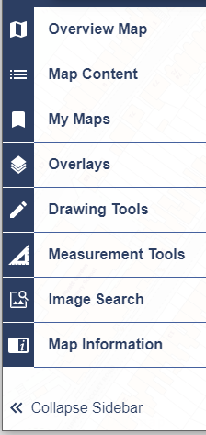

Map information
Select Map Information in the sidebar to find information on the map you are viewing. Available fields vary between collection but will typically include:
- The name of the map you are viewing.
  - NOTE: In Historic Digimap, the name of the map on display is available through the feature information tool.
- The date of publication.
- Data Licence.
- Default Print Scale.
- Map projection, such as British National Grid.
- The grid reference, the British National Grid coordinates and the latitude and longitude for your current position.
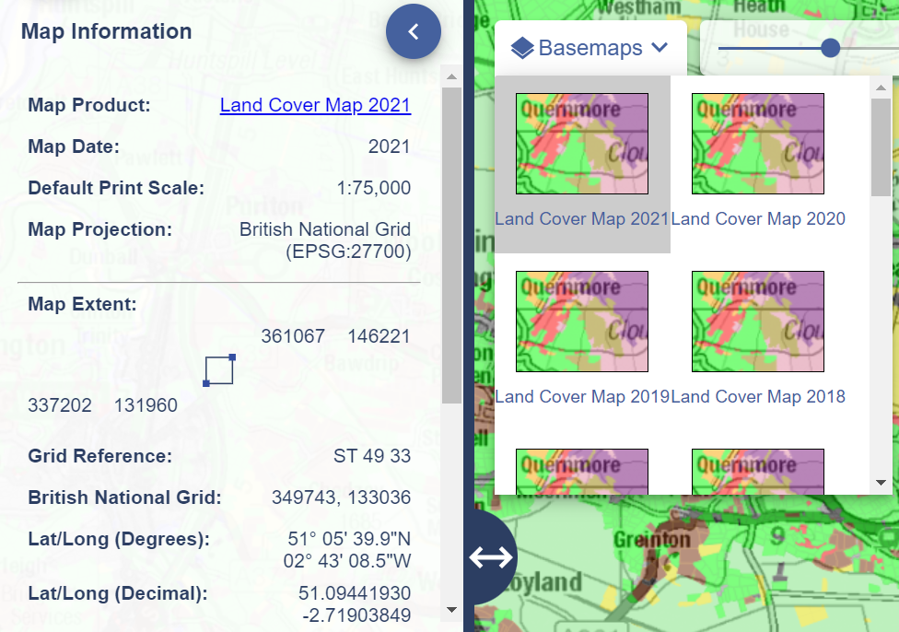

Coordinate Capture Tool
You can capture geographic coordinates for a specific point on your map,
- Select Map Information.
- Move the Coordinate Capture tool slider to the right.
- Select a location on the map.
- The coordinates are displayed in the Map Information window and a marker is placed on the map.
- You can copy and paste the text from the Map Information window if you need to save the coordinates.
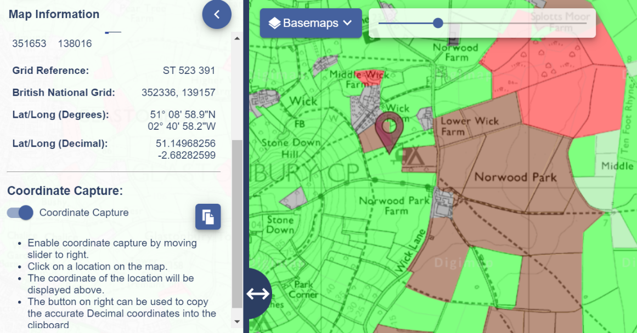

Map content
In several collections, you can choose what features to display on the map.
- Select Map Content from the sidebar.
- Uncheck any box to remove those features from your map.
- Select the arrow left of any box to view the features in that group.
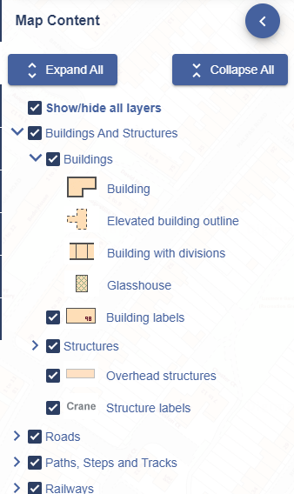

I can’t select anything
The message 'This view has no layer selection' means you can't select map features (because of the type of map data on display). Try a different Basemap to see if feature selection is available.

Drawing tools
You can add text, markers, buffers, pre-defined shapes, images and polygons to your map.

Create drawings
- Select Drawing Tools from the sidebar.
- There are 3 tabs: create, import and export.
- On the create tab, you can:
  - Add markers – select any symbol, click on the map where you want to place it.
  - Shapes – select the shape, choose your fill and stroke colours. Click once to start drawing, then drag the mouse to draw and rotate your shape.
  - Lines – select the relevant button, choose your stroke colour. Click on the map to start drawing – click once at each point and double click to finish.
  - Text – select the Text button, choose your text colour and size, click on the map, type your label and select OK.
  - Measure – select the icon to add measurement (length or area).
  - Image – select the Image button, choose a marker. Select your spot on the map, navigate to your image and select Upload.
  - Gridref – add a grid reference marker. Select the gridref marker, select a point on the map.
  - Buffers – select the buffer tool and choose a point or line buffer.
    - Enter the radius of your buffer – a dropdown menu lets you choose between metres, kilometres or miles.
    - Line buffer? Draw your line on the map.
    - Point buffer? Click or tap on the map at the point you wish to be at the centre of your buffer.
- A feature is selected when it is highlighted in yellow on the map.
- To move a feature just select and drag to its new location (ensure the Select arrow is highlighted in yellow).
- Select a group of features with the Select box tool.
- Delete all features with the Delete All button.
- Delete individual features with the Deleted on click button.
- Modify features – only becomes active when a feature is selected.
  - You can add measurement labels, move, scale, rotate and transform features with the tools in the modify menu.
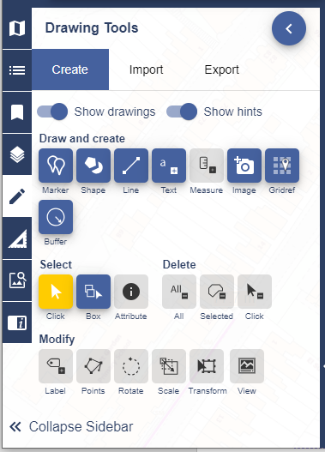

Export drawings
You can export your drawings in file formats that are compatible with GIS software.
- Select the Export tab.
- Select your format choice; Shapefile, KML or GeoJSON.
- Name your file.
- Select Export.

Import drawings
You can import drawings. This option may be useful if you’ve collected geographic data and wish to display it on your map. **Your file must be a maximum of 10mb and one of the following formats; Shapefile (in zip), KML, GPX, CSV or GeoJSON.**
- Select the Import tab.
- Select Choose File.
- Navigate to your file location on your device.
- Select Open.
- Select import to display the data on your map. NOTE: if your data is CSV format, you will be asked to identify which of the columns in your file are the X and Y coordinates.

Measure
Our Measurement Tools, in the sidebar, let you measure the distance or area of any map feature.
- Select Measurement Tools on the sidebar.
- Choose Distance or Area.
- Click or tap once on the map to start measuring.
- Click or tap at each point of your line or area.
- Double click or tap to finish measuring. The total distance or area measurement is displayed in the measurement tools area and on your map.
- Measurements can be deleted using the Delete measurements button.
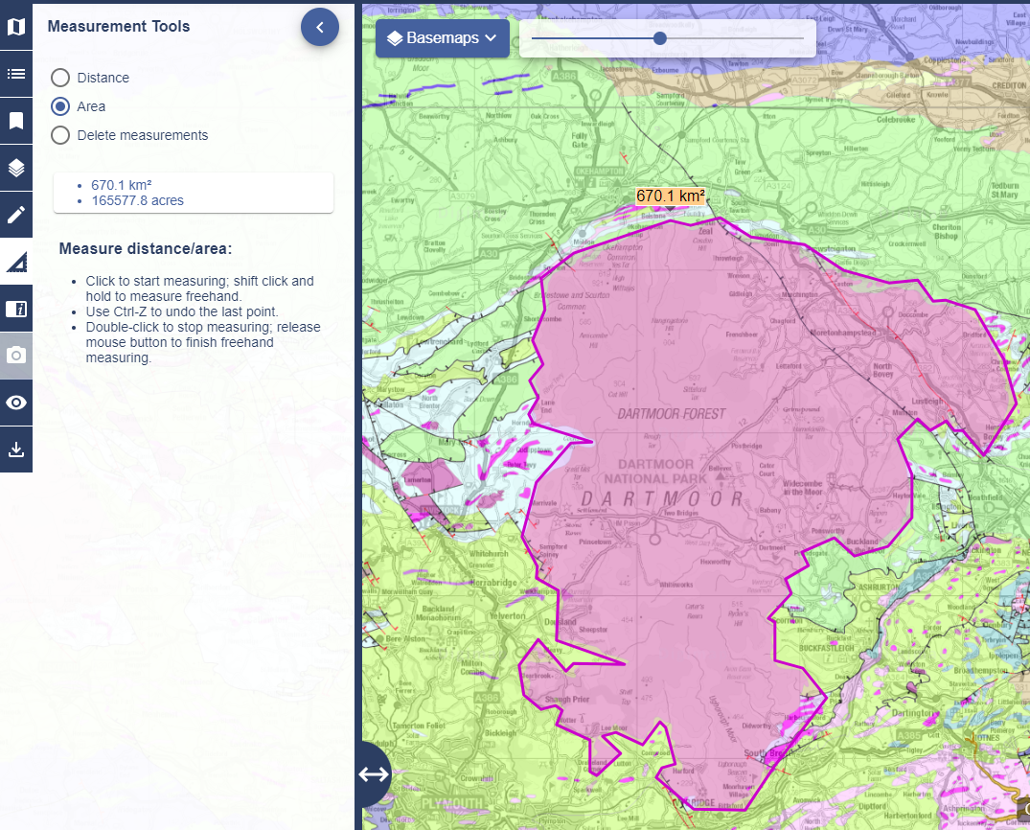

Measurement labels
You can add measurement labels to any lines or shapes that you add with the drawing tools. You will find this option in the Modify area of the Drawing Tools.
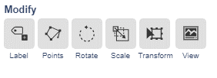

Save and open maps
- Select My Maps from the sidebar.
- Save – to save your map and drawings, enter a name and Select Save.
- Open – just select any map you have previously saved, to display it in the map window.

Overlays

Add hill shading
You can select to add a 3D terrain backdrop to your maps, to give a clearer idea of the terrain in your area.
- Select Overlays from the sidebar.
- Tick the Hill Shading box. Boxes that cannot be ticked, are in a brighter grey. This changes as you zoom your map in or out. It’s most effective when you are zoomed out and in higher areas.
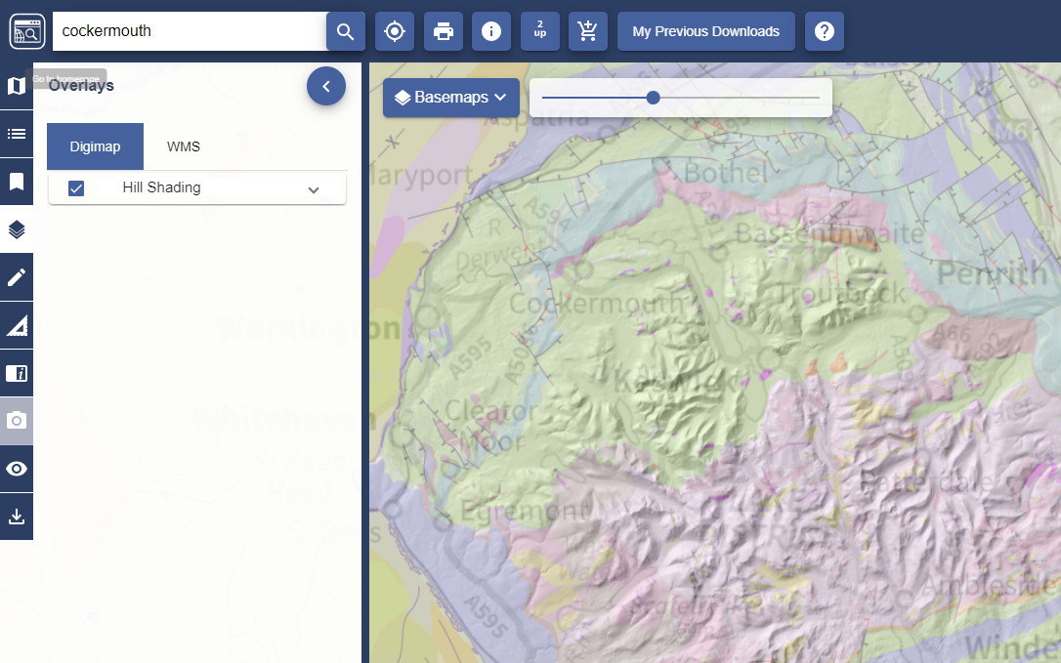

Overlay Points of Interest
Only found in Ordnance Survey Collection, this allows you to view the locations of over 600 different types of feature. Categories include Accommodation, Commercial Services, Attractions, Sports, Education and more.
- Select Overlays.
- Zoom in until Points of Interest is available – you will know as the box will not be greyed out.
- Select any category of interest to display the points.

Overlay Postcodes
Only found in Ordnance Survey Collection, this allows you to view postcode boundaries. As you zoom in, more detailed postcodes are displayed.
- Select Overlays.
- Select Postcodes (see image below).
- Zoom in on your area and you will see the postcodes change from:
  - areas e.g. NG, to
  - districts e.g. NG23, to
  - sectors e.g. NG23 6
  - units e.g. NG23 6NY
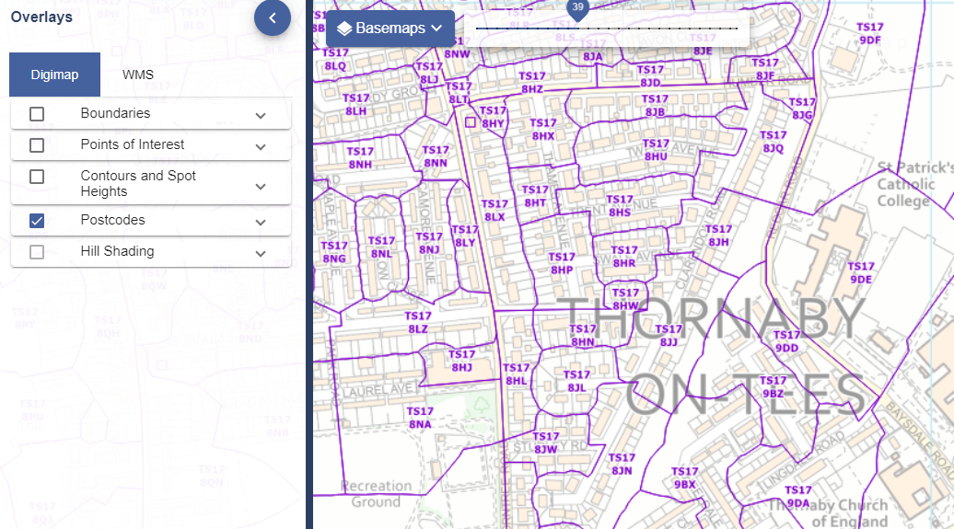

Overlay Contours and Spot Heights
Only found in Ordnance Survey Collection, this allows you to view contours and spot heights.
- Select Overlays.
- Zoom in until Contours is available – you will know as the box will not be greyed out.
- Select Contours and Spot Heights.
- Select a category or display all, from:
  - Contours
  - Mean high and low water
  - Spot heights

Overlay road/place names
Only found in Aerial Digimap, this option allows you to view road and place names on the aerial maps. It is found within the Overlays menu.
- Zoom in until an Aerial map is displayed.
- Select Overlays from the sidebar.
- Tick on the Road/Place box – you can click when the box is not greyed out.

Add a Web Map Service (WMS)
This option, available on a tab in the Overlays menu, allows you to add a web map service of map data and view it, overlaid, on your map. In the sample image below, an elevation map of the UK has been added.
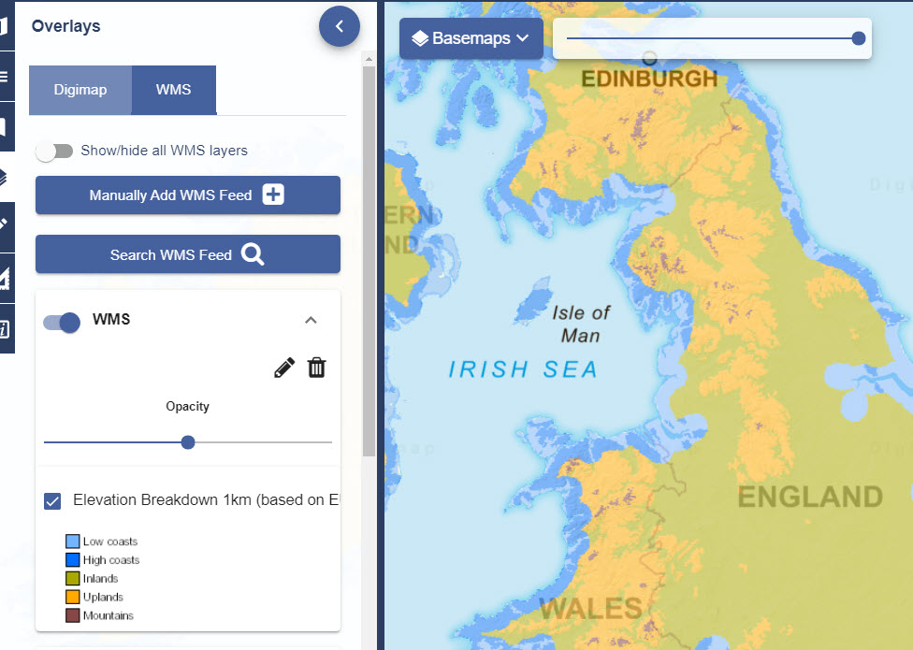

Add a WMS from Digimap’s list
- Select Search WMS Feed.
- Check the box next to any WMS to select it.
- Select Add Selected Layers to map.
- Your WMS should be visible in the WMS tab and your map display changed.

Add a WMS you have sourced
- Select Overlays from the sidebar.
- Select the WMS tab.
- Select Manually add WMS Feed
- Paste your link into the first line of the box, titled ‘3rd Party WMS URL’.
- NOTE: if your URL has HTTP at the beginning, please change this to HTTPS.
- Select Get Layers.
  - Select the eye icon to turn a layer on or off.
  - Use the arrows to change the order of display of any layer.
  - Select the pencil icon to edit the name of any layer.
- Select Add Layers to Map.
- Your WMS should be visible in the WMS tab and your map display changed.

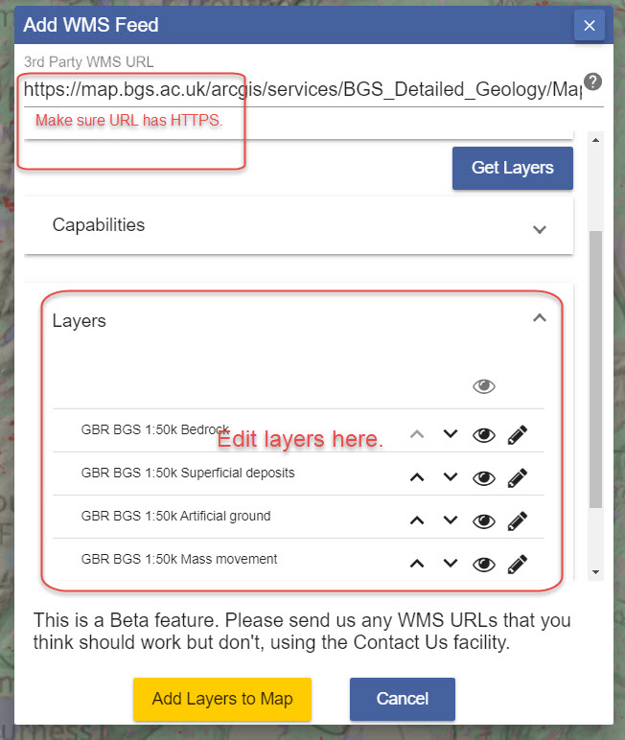

WMS settings
- You can switch WMS on or off in the WMS tab. Just select the button next to each WMS on or off.
- There is an opacity slider under each WMS to let you adjust your map display. Just move it left or right to see more or less of your WMS map data.

Add map data
There are 2 ways to add data into Digimap.

Import a file
- Select Drawing Tools, then Import.
- Compatible formats are Shapefile, KML, GPX, CSV and GeoJSON.

Add a Web Map service
See notes above.

Overview map
An overview map, identifying the location of your current map, is available.
- Select Overview map from the sidebar.
- The small red box (highlighted on the image here) indicates your current position.
- You can select the red box and move it around to change position.
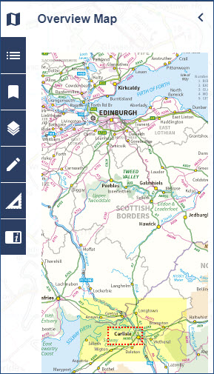

Active Legend
Only found in Geology Digimap, this tool lets you highlight any geological feature on the map and view its legend entry.
- Find your location.
- Open the Active Legend from the sidebar – the eye icon.
- You will see a legend with different categories, e.g. bedrock, superficial deposits. The categories will vary depending on your current scale.
- Select the arrow next to any category to open it and view a legend.
- Select any feature from the legend to highlight it on the map.
- You can also select anywhere on the map and the feature will be highlighted in the legend.
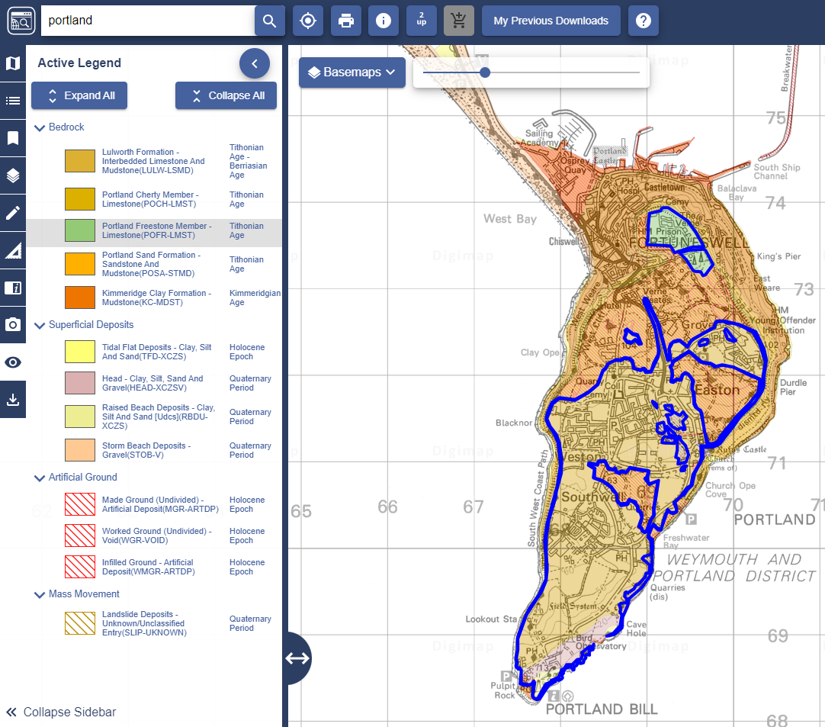

Geological Photos
The Geology map offers geological photos from the British Geology Survey. There are around 3000 images available, only available in the 5 most detailed map views.
Members of the BGS have taken photos of rocks, landforms and other geological features in the landscape. These are concentrated mainly in upland areas such as Cumbria, the Peak District, North Wales and the Dorset Coast.
- Find your location.
- Zoom in to one of the 5 most detailed views.
- The Geological Photos option on the sidebar will change colour, if there are photos available.
- Select Geological Photos from the sidebar.
- A list of available images will be displayed in the sidebar, and camera icons will appear on the map wherever there’s an image.
- Select any image from the list, or any camera icon, to view a thumbnail image in a pop-up box.
- You can select the image to view a larger image plus image information.

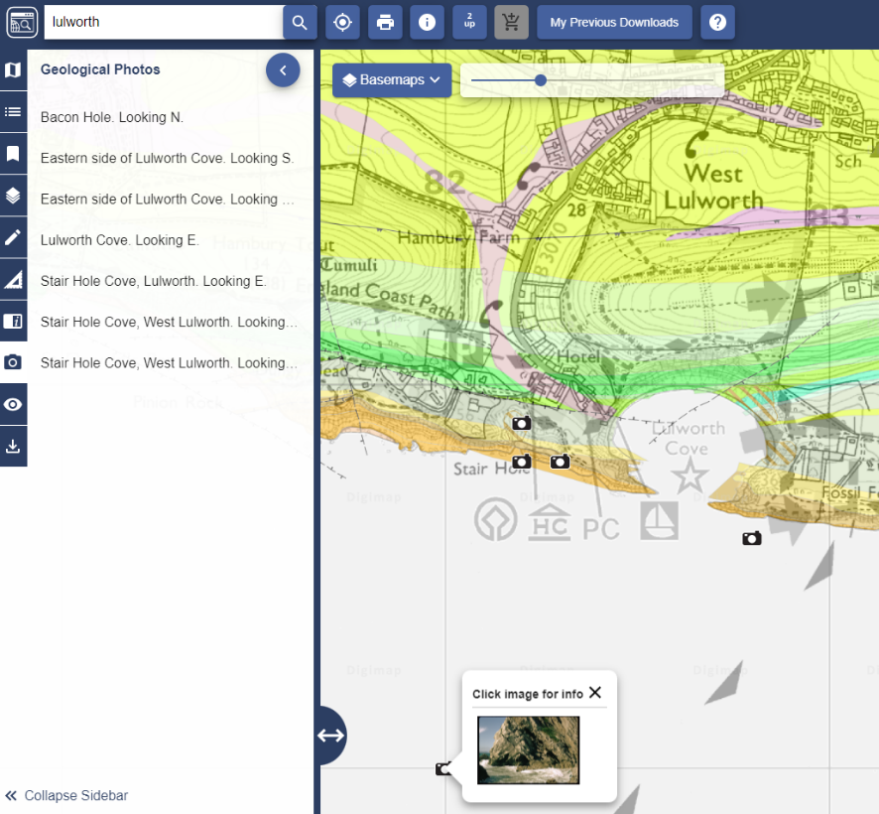

Save screen image
Only found in Historic Digimap, this tool lets you capture
- Zoom in to a historic map.
- Select Save Screen Image as from the sidebar.
- Select PNG or JPF format.
- Select the Save image button.
- An image of your map, with a copyright statement, is generated.
- You will be prompted to save the image on your device.

Overlapping map selection
Only found in Historic Digimap, this tool lets you select which map to view. You may find, when browsing the historic maps, that from time to time the maps look blurry. This can be the result of more than one historic map being displayed.
Before WWII, mapping in Great Britain was created on a county basis. Often the surveyors mapped a little in over the county boundary, meaning that when we display the maps available for an area from a decade, there can be more than one.
- Find your location.
- Blurry map? Open the Overlapping Map Selection tool, from the sidebar.
- You will see a map with some outlines on it. Under the map will be a list of the maps on display.
- Select any map from the list, to see the area it covers on the small map.
- When you select any map from the list, the map in the map window changes to reflect your choice.

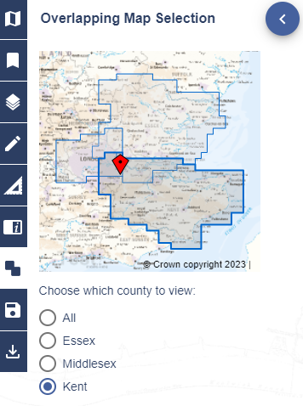

Copyright

What can I do with maps from Digimap?
You can check the licence agreements and Frequently Asked Questions at the link below.
https://digimap.edina.ac.uk/webhelp/digimapsupport/about.htm#access/licence_agreements.htm

What is the correct copyright statement?
Any map you print from Digimap will have the copyright statement printed on it, at the bottom left of the map.
You can also check our blog post below for advice:
http://digimap.blogs.edina.ac.uk/question/what-is-the-appropriate-wording-for-the-copyright-statement/

Find Help and Support
- Select Help, at the right of yout top banner to find help pages and other resources.
- Select the icon with the two bubble speech on the top banner to submit any questions.

